Dear Students,

For your project, please prepare **one PDF file** report containing the following elements. Make sure to include all of the elements – No further report submissions will be allowed.

1. Current status of the project implementation:
   * List of fully implemented use-cases / functionalities
   * List of partially implemented use-cases / functionalities. Give the percentage of implementation.
   * List of use-cases that have not been implemented.
2. Team member contributions.
   * For every team member detail the list of accomplished tasks by the member, **and** the overall contribution percentage to the project (%).
   * Team coordination: describe in a concise way how the team members collaborated to achieve the project. List the collaboration tools that you have used, if any.
3. Visual overview of the project. Walk the report reader with your application by providing pictures of various pages and use cases as well as the control flow between pages.
4. Design diagrams: Give all the design diagrams that you have established: control flow (for pages), entities, etc.
5. For verification, provide the source code of your project in one of the following ways:
   * Share your project with me on Github
   * Provide a link to download a zipped folder containing your (e.g. through google drive).
6. Use the template below for your reports

**Send your report by email to** [**mbarhamgi@qu.edu.qa**](mailto:mbarhamgi@qu.edu.qa) **and CC barhamgi@gmail.com**

Thank you  
Good luck with your projects.

|  |  |  |
| --- | --- | --- |
|  | **CMPS 350 Project Phase 1 – WebApp UI Design and Implementation**  **Conference Management System (ConfPlus)**  **(20% of the course grade)** | |
| **Group Members:** | | Abdulla Al-malki (202009135)  Ahmed Deef (201606478)  Mohammed Al-Obaidly (201801987)  Youssef Ahmed (202107162)  **Emails:** [aa2009135@qu.eu.qa](mailto:aa2009135@qu.eu.qa)  [ya2107162@qu.edu.qa](mailto:ya2107162@qu.edu.qa)  [ad1606478@qu.edu.qa](mailto:ad1606478@qu.edu.qa)  ma1801987@qu.edu.qa |
|  | |  |

**Grading Rubric - In the Functionality column please specify either: *Working (completed x%)*, *Not Working (completed x%)* or *Not done*.**

|  |  |  |  |  |
| --- | --- | --- | --- | --- |
| **Criteria** | **%** | **Functionality\*** | **Quality of the implementation** | **Your Grade** |
| **Application Design:** Entities, Repositories and Web API class diagrams, flow diagrams | 10% |  |  |  |
| **Complete and correct implementation of the requirements:** | **80%** |  |  |  |
| * Login | 10 |  |  |  |
| * Submit paper | 20 |  |  |  |
| * Review paper | 20 |  |  |  |
| * Create/update conference schedule | 20 |  |  |  |
| * Get conference schedule | 10 |  |  |  |
| **Testing, documentation, and group work:**   * Use screen shots to illustrate your tests. * For every team member detail the list of accomplished tasks by the member, **and** the overall contribution percentage to the project (%). * Team coordination: describe in a concise way how the team members collaborated to achieve the project. List the collaboration tools that you have used, if any   **All of these elements should be reported in the template below** | 10% |  |  |  |
| **Total** | 100 |  |  |  |
| Copying and/or plagiarism or not being able to explain or answer questions about the implementation | -100% |  |  |  |

**\* Possible grading for functionality** - ***Working*** (get 70% of the assigned grade), ***Not*** ***working*** (lose 40% of assigned grade and ***Not done*** (get 0). The remaining grade is assigned to the quality of the implementation.

In case your implementation is not working then 40% of the grade will be lost and the remaining 60% will be determined based on of the code quality and how close your solution to the working implementation.

Solution quality also includes meaningful naming of identifiers (according to Android naming conventions), no redundant code, simple and efficient design, clean implementation without unnecessary files/code, use of comments where necessary, proper code formatting and indentation.

**Marks will be reduced** forcode duplication, poor/inefficient coding practices, poor naming of identifiers, unclean/untidy submission, and unnecessary complex/poor user interface design.

# Current status of the project implementation

**Fully implemented:**

* **Login** – html/css/client-side/server-side
* **Schedule** – html/css/client-side/server-side
* **Submit paper** – html/css/client-side/
* **Review paper** – html/css/client-side/
* **Home Page** – html/css/client-side/server-side

**Partially implemented:**

* **Submit paper** – server-side (pdf upload and download not implemented)
* **Review paper** – server-side (pdf upload and download not implemented)

**Not implemented:**

* Upload PDF
* Download PDF

# Application Design

# Entities class diagram

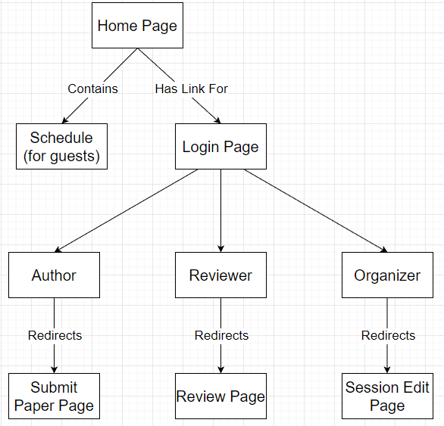

# Repositories class diagram

Repositories were distributed in the API based on their uses. For example, “api/sessions/” has its own repository file for session uses, and “api/papers” has its own repository file for papers uses, and etc.

# Web API class diagram

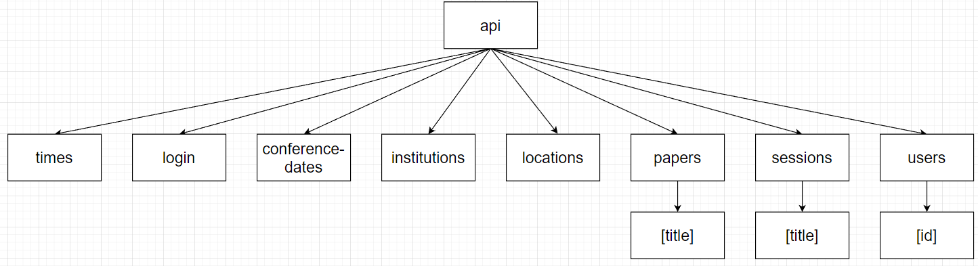

# Testing

# Login

**Test wrong account**

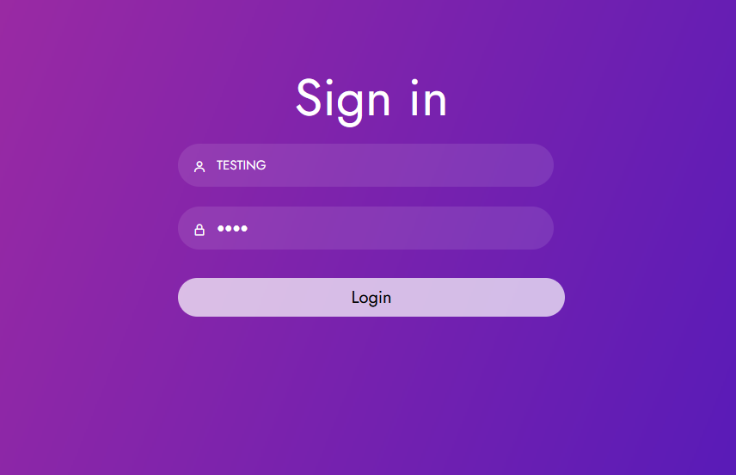

**Correct account redirects to the user’s page.**

# Submit paper

**

**Presenter is chosen and more authors can be added.**

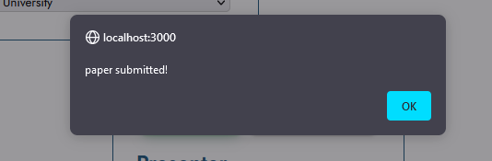

# Review paper

**Showing & collapsing abstract**

**collapse**

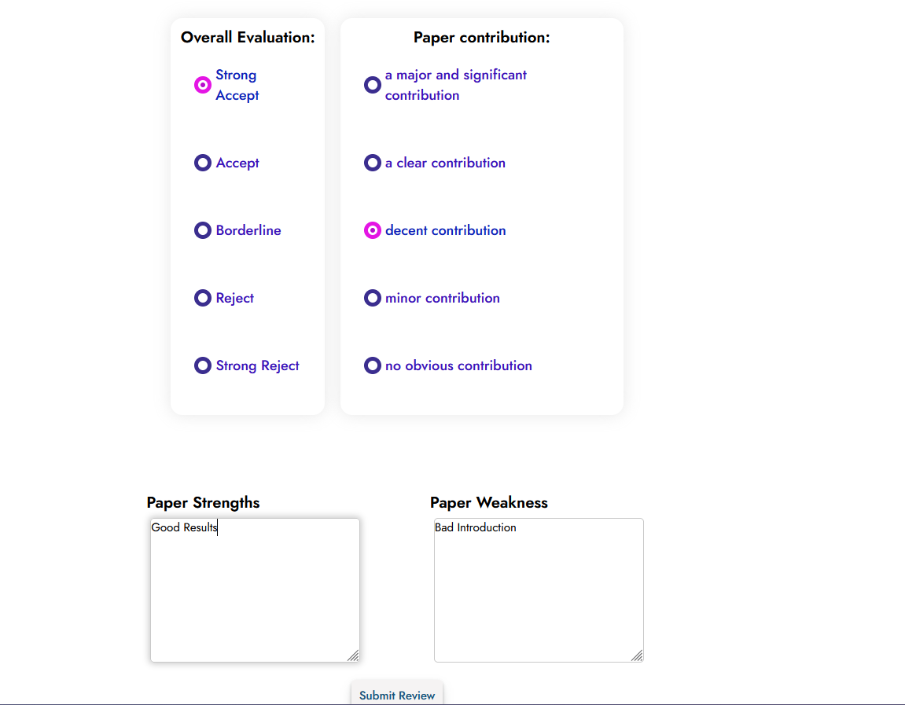

**Getting message if the review got submitted**

# Create/update conference schedule

**Viewing available sessions and having the ability to delete/update them**

**adding new session**

**Getting alert when session is submitted**

**Sessions can be deleted too**

# Get conference schedule

**The home page views the schedule for guests**

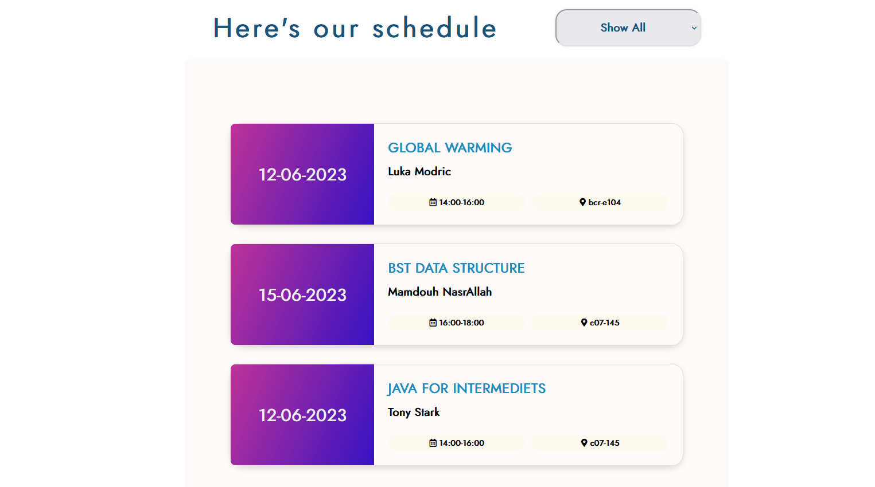

**The schedule can be filtered**

# Discussion of the project contribution of each team member

# Team member contributions

**Abdulla: 25%**

* Designed the initial structure of the project (html, simple sketch for the UI).
* Designed the web diagram.
* Programmed the login page client-side & server-side.
* Assisted Ahmed in enhancing responsive CSS layouts.
* Assisted in tweaking some issues.

**Ahmed: 25%**

-Reimplemented HTML, CSS and used Figma software to get the right blueprint for all pages structure and styling.

- Programmed the client side of the Home Page with rendering the sessions and programming the filtration.

**Mohammed: 25%**

* Designing and programming the server-side implementation of the schedule (/api/sessions and /api/sessions/:title), as well as the final structure of the organizer’s schedule page and session cards, as well as the functionality of said page, but not the page’s styling past some basic structural elements.
* Ensuring that the papers’ reviewer objects functioned properly by providing feedback as well as some minor code modifications, due to it being important for the functionality of the schedule page.

**Youssef: 25%**

-Made the server-side implementation of the papers: getting and posting papers as well as getting and updating a specific paper through web api (api/papers – api/papers/[title]).

- Made the client-side JavaScript implementation for submitting papers (submit.js) and reviewing papers (review.js).

# Team coordination

We worked as a team using GitHub repository for working on the project, WhatsApp group to discuss our work, and Discord to screen share our work. We had one real-life meeting in the beginning of the project to divide our work and understand the project pdf file requirements.